**5)- How to put DOS attack on any network and also explain how you identify that its an attack by using wireshark logs**

**We use hping3 – in this case we can also specify the port number change our source ip (spoof the source ip ) and can also do flooding with different ips.**

**Command usage –**

**hping3 host -(variable)**

**-c - count packet**

**--flood - sent packets as fast as possible. donot show reply**

**-a spoof source address**

**fragments packets can passes through firewall**

**-s change the port non-authorization**

**-p change destination port**

**-xmas -finish,urgent,push(if a particular flag not allowed)**

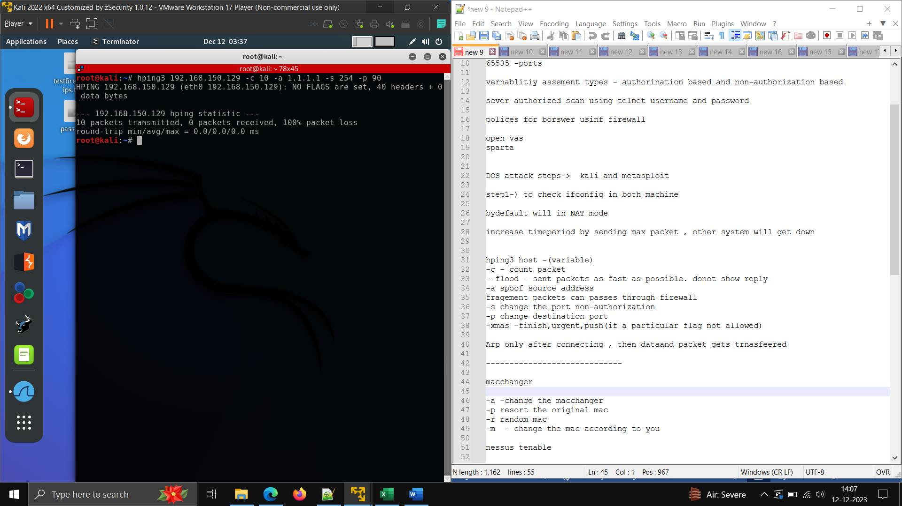

**Here we have spoof our ip -1.1.1.1 and change the destination and source port and send total 10 packets**

**Now we will flood the ip traffic and monitor it in wireshark - >**

**Note – in flood mode no replies come**

